The National Physical Education Institute
Website: www.nationalpe.com
July 28-30, 2014
Asheville, North Carolina

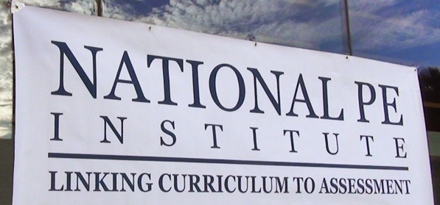

We want YOU!
Are you a physical education teacher who is always seeking and searching to make your program the best it can be? If so, consider joining us at the 2014 National Physical Education Institute this summer! Like the inspirational TED Talks, the National PE Institute was designed to inspire and motivate K-12 physical educators seeking to “challenge the status quo” in their daily professional lives.
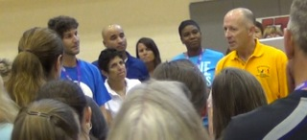

Join the Conversation!
By attending this year’s Institute, participants will be able to see and learn from the brightest and best physical education experts ever assembled under one roof! Here’s a few of the talented and exceptional individuals coming this year: Dr. George Graham, Jean Blaydes, Dr. Bob Pangrazi, Joey Feith, John Smith, John Thomson, Chip Candy, and more! To see the rest of the keynoters and National TOYs, please click here: http://nationalpe.com/keynoters/

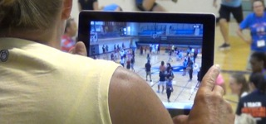

Special Learning Tracks
In addition to this conference’s Innovation and Technology focus, we have created two special learning tracks for this year’s Institute. They include:
- Adapted Physical Education: Led by a terrific cadre of outstanding APE experts coordinated by Dr. Diane Craft (SUNY Cortland), Jim Rich, Jolanda Hengstman, and Barbara Meleney.
- Central Office Directors: Each day will feature a special networking session for Central Office and Lead PE Teachers.

For More Information: Please feel free to call the Great Activities Publishing Company at 800.927-0682 for additional information. Hope to see you there!

