**Solving the Obesity Crisis Part II: A Simple Plan**

In January’s *pelinks4u*, I shared some issues that seemed to me to be most important in addressing the obesity crisis. They were mostly observations about the challenges we face rather than practical solutions. So, this month, I’m sharing a perspective on how we as physical educators could take steps to address the key causes of obesity: poor diet and insufficient physical activity.

I should probably apologize at the outset that the plan I propose is not very sophisticated. In fact it’s downright simple. But it puzzles me that many of the interventions I currently see being tried have no hope of being successful. For example, recently in one of our local schools a grant provided small sacks of fresh vegetables to elementary grade kids. The kids loved them. And presumably it was a healthy alternative to their typical diet. But then the grant ended and with it the fresh vegetables. Who knows how much this intervention cost, but I doubt it changed the kids eating habits.

Around the country I read about the introduction of special programs designed to promote physical activity or improve eating habits. Although well-intentioned, I don’t see the point unless they’re sustainable without grant support. It’s a bit like sending someone - at no charge - to a health spa for a couple of vacation weeks. Instead of working and other daily drudgery, they enjoy healthy dining and free recreational physical activities. In this new environment it’s pretty easy to adopt a healthy lifestyle. But this misses the point. If we can only stay healthy when we have easy access to spas, pools, gyms, parks, trails and the like, we’ll never turn back the obesity tide. To solve obesity it’s much more important to think creatively about what we can do in our existing environments, not some inaccessible, artificial, or temporary alternative.

As I noted last month, the focus has to be on changing people’s lifestyle behavioral patterns. Healthy people don’t do anything special to stay healthy. Their lifestyle is health promoting because of their daily behavioral habits. Where a choice is to be made they choose the healthy option: not because it’s healthy but because it’s their preferred choice. So with this in mind here’s a simple plan for solving worsening obesity among students.

Each day consists of time during which we are either consuming or burning calories. In the case of kids, typical activities during the school day are illustrated in red in figure 1.

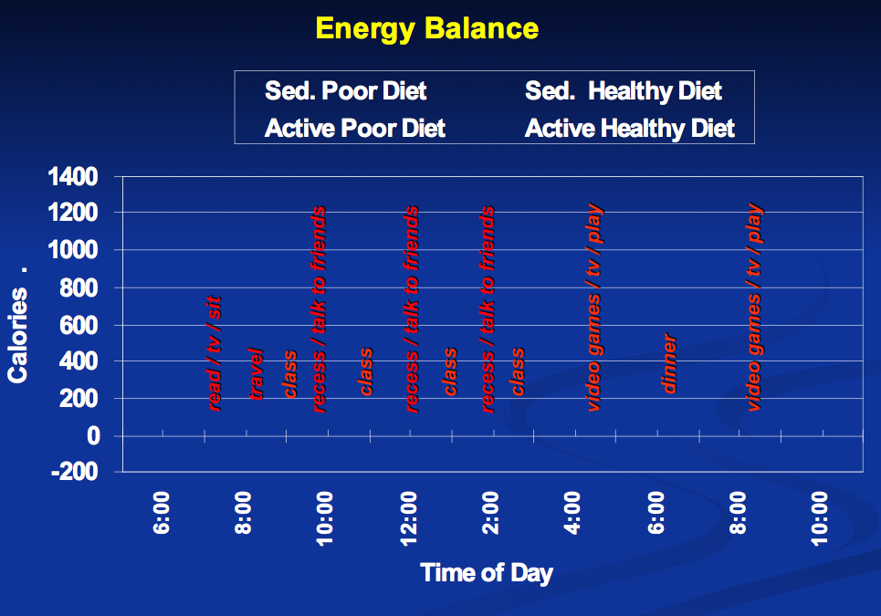

Figure 1: Children’s Daily Activities

As you can see kids wake up, dress and eat breakfast, get ready for school and then somehow get from the home to school. Arriving at school they either go to the classroom or spend time on the playground. Classes begin and continue until morning recess (unless it’s been eliminated), then return to classes until noon recess. They now have time both in the lunchroom and on the playground before returning to class. Mid-afternoon, school ends whereupon kids travel home, remain for some afterschool activity, or go to a day care facility. By early evening they’re back home, eat dinner, and do some kind of activity before bedtime. For most students across the United States – indeed the entire Western world – this schedule varies little for 12 or more years.

Looking at it another way, the day of a K-12 student is an ebb and flow of calorie consuming or calorie burning activities. This is represented in figure 2. In this case, Dr. Kirk Mathias, my colleague at Central Washington University, reviewed typical food choices and constructed sample “healthy” and “poor” (unhealthy) daily diets. He then examined likely energy expending activities throughout the day. Combining these two data sources he was able to create typical energy balance graphs for both sedentary and active students.

Several interesting observations emerged. First, it appears that of the four groups shown, only active students who eat healthy diets burn more calories than they consume. Every other group consumes excess calories. Second, regardless of whether sedentary students eat healthy or unhealthy diets, they still consume more calories than they burn – hence the weight gain. Third, and perhaps most importantly for physical educators, any intervention throughout the school day that increases student expenditure of calories has the potential to change the final outcome of any of these graph lines.

So, for example, an intervention such as adding an active form of transportation to school (e.g. walking, bike riding, walking school bus, etc.), can provide some students with enough physical activity to balance their caloric intake. Creating more opportunities for playground play prior to the start of school, starting the school day with a short physical activity, taking classroom physical activity breaks during the day, adding more physical education, improving school lunches, ensuring that all children take recess outside, switching the content of vending machines, and eliminating unhealthy classroom snacks are all relatively easy to implement interventions to change the energy balance situation. And the addition of active after school physical activities between the on average 3 hour end of the school day and evening dinner could completely reverse the trend toward excessive caloric consumption.

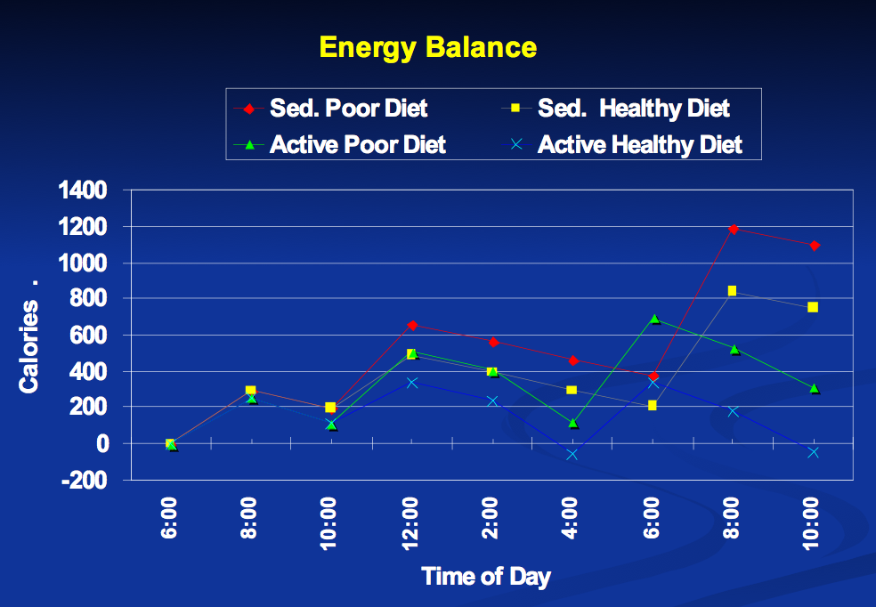

Figure 2: Energy Balance of Children on Healthy and Unhealthy Diets

And finally, three ways in which this obesity reduction plan differs from many current initiatives: (1) It could be introduced relatively easily into every school environment across the United States; (2) It wouldn’t require a huge funding investment to become sustainable; and (3) It is focused on creating permanent, habitual, health-promoting lifestyle behaviors among today’s youth.

Steve Jefferies, Publisher

Pelinks4u