Tips and Tricks to using Excel to collect student data

Freezing Panes
Freezing panes is a must when using Excel for attendance, assessment and grading. I always select the columns I always what to see, like the students first name, last name, and class then freeze the pane right after so that I can move the rest of the worksheet and still see the those columns.
To freeze the pane, highlight the whole column right after the column you want to keep. Then go to the Windows menu, and click on Freeze Pane. There you have it, a worksheet that scrolls.

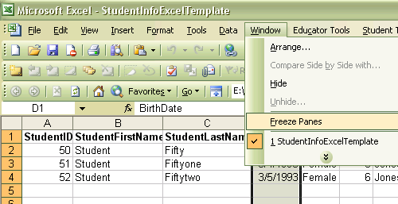

Selecting the whole worksheet to Sort Data
Use the upper left hand border box to select the whole worksheet prior to sorting by columns. This way you can sort all the data. I usually sort each class by Gender, LastName, and FirstName columns. This makes it easier to interpret data later, and is important for analyzing physical fitness scores.

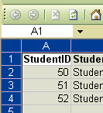

Using Excel on a Windows Mobile Device or Pocket PC
Since Excel is native on Pocket PCs it is great to use for collecting student assessment data. I most frequently use it when I cannot carry my Laptop, or am away from my computer on a cart. It makes it easier to circulate through the class, and assessing each skill, movement pattern or routine. The trick to using the PDA is freezing the right panes and reducing the size of the columns to fit the PDA screen. I usually reduce the Last Name column to see only the first letter and freeze the pane after the First Name column. Freezing the pane is done as shown above.
Reducing column width is pretty straight forward. You click on the right hand edge of the column header row …

…Then drag until it only shows the first digit or letter. Results look like:

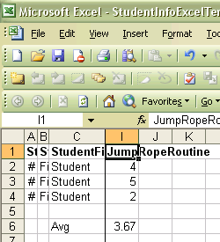

To organize your classes, you have two options. Option 1: Save each class as a separate file with various semesters or grading period on a separate worksheet. Option 2: Save each class as a separate worksheet with the same workbook or file. Option 2 is the method I tend to use most often, and feel comfortable with. It saves space, it is easier to find, and navigate to different worksheets. Use the Insert Menu and Choose Worksheet to create worksheets within the workbook for each class. They will show in a tab at the bottom of the worksheet.

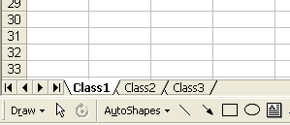
It is also easier to move student from class to class when needed. Once saved in your shared PDA folder, then open and use it on your PDA. (The above scenario is very similar when using a palm powered device with Pocket Excel)

Summarizing Data using the Formula Bar in Excel
To average or sum data in a worksheet, you use the formula bar. Select the formula you want to use; the cells you want to calculate and hit enter.

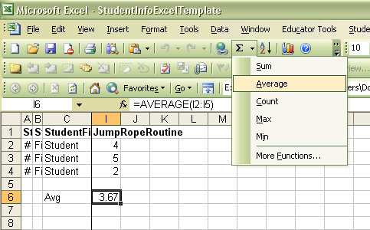

Creating Charts and Graphs in Excel
To create a graph or chart in Excel select the data, header and row cells you want to include in your graph. Then click the Graph Tab in the menu bar. The wizard will guide you through your choices, and then you have the graph of your choice.

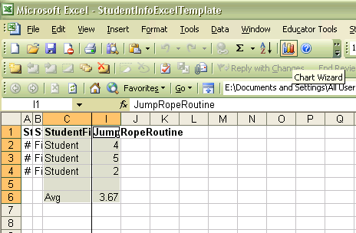
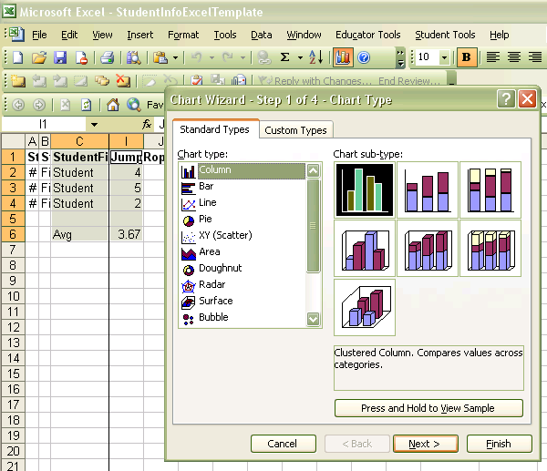

Click next after selecting your preferred graph type.
Choose row or column data.

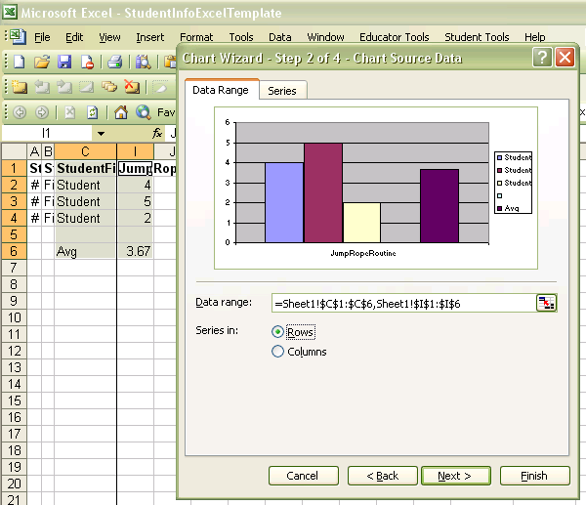

Then click next. Fill in the Chart header, X axis label, and Y axis label and click next.
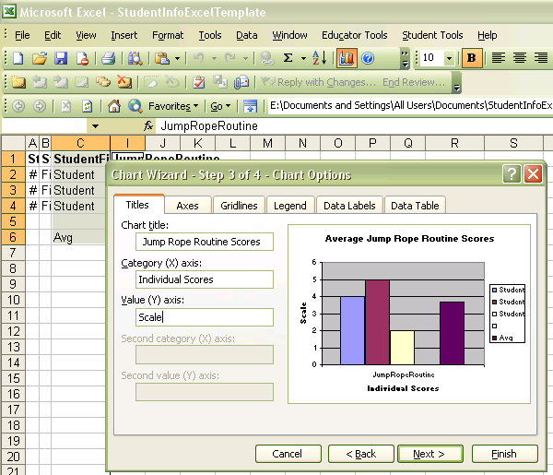

Click Next…
Choose whether you are going to place the graph on the current worksheet or another worksheet. I prefer to place my graphs on another worksheet.

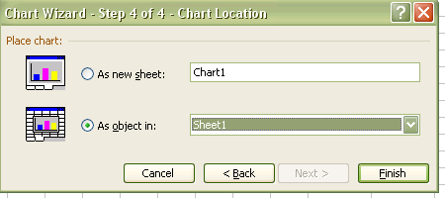

And click Finished… (more continued below)
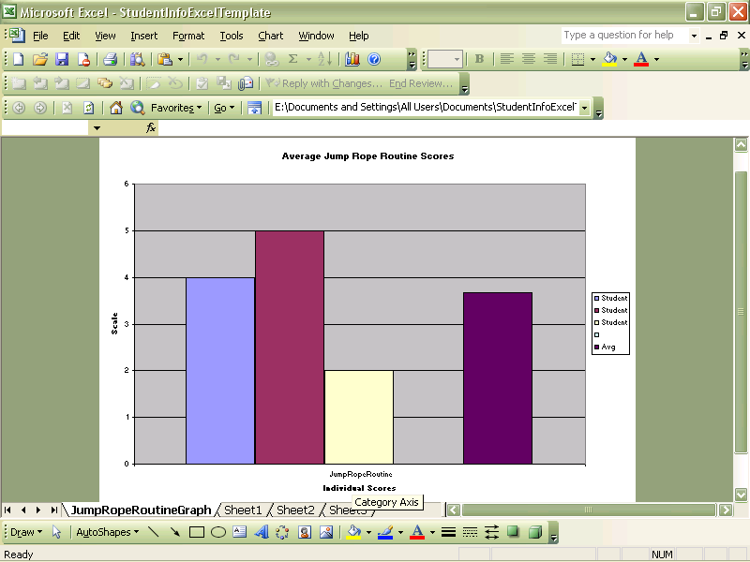

Graphs are great for teacher portfolios, displaying data so students can better understand where they fall in the grading spectrum, or for use in reports home.

