Dixon Den Money Chant (morning meeting)
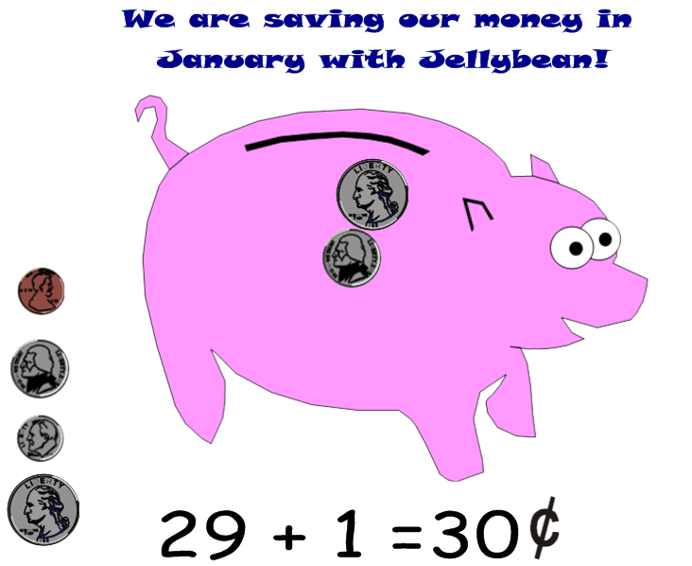
Penny one cent, (stretch right arm up with one finger up)
Nickel five cents, (stretch left arm up with five fingers up)
Dime ten cents, (stretch both arms up with ten fingers up)
Quarter, twenty five! (jump as high as you can with both arms up)

