SELF-DEFENSE ESCAPE SKILLS

Balance, Stance, and Movement Drills

Balance Drills on Mats – Individuals should gain a physical understanding of what it feels like to be properly and improperly balanced. To begin stand face to face with a partner and clasp hands at shoulder height. With feet together, push against your partner in order to knock him/her off balance, indicated by taking a step in a backward, sideways, or forward direction. Try this drill again with feet at shoulder width and then again with feet as wide as they will go. A majority of people will feel most comfortable with their feet at shoulder width, however still be prone to being knocked off balance. For the final drill, stand with feet at shoulder width but this time take a step back with your dominant foot. You are now in a position that allows for dynamic balance in forward, sideways, and backward planes.
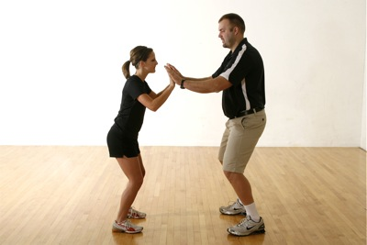

Balance Position – A balance position is an efficient stance that provides comfort, mobility, efficiency, and ultimately safety for the individual. It is important that students stand sideways to the aggressor, with their hips approximately 45 degrees from the threat. Beginners tend to stand square to their attacker, creating the largest target possible. The balance position is the first, and most important physical skill to be taught in any self-defense educational unit. The balance position will be the primary stance used within self-defense.
Instructional Cues
- Feet are shoulder width apart with dominant leg one step back
- Weight is evenly distributed on the balls of one’s feet
- Hips are located at 45 degrees from the assailant
- Shoulders are squared to the assailant
- Arms are up, elbows in, and fists are clenched (thumbs outside of fingers)
- Head is protected “in the box”
- Eyes are on the horizon

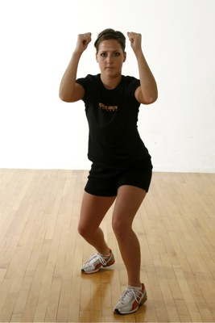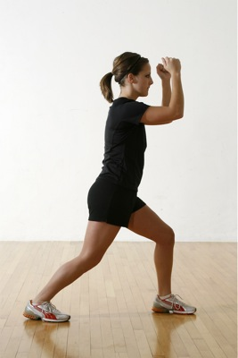

Balance Position Slides – An attack situation is very dynamic, and depending upon the context in which it takes place, an individual must be able to move and react accordingly. To develop forward, sideways, and backward movements, begin by spreading students evenly throughout the gymnasium. A simple way to accomplish this is to assign squads and then have each squad always go to same line within the gymnasium. Now that the environment is organized, the instructor is able to lead the class in the following drills.
Instructional Drills
- Developing Student Response to Instructor’s “Balance Position” Cue – With students spread throughout the gymnasium, the instructor first calls “Balance Position”. All students should immediately drop into the appropriate stance. The instructor is able to visually monitor the gymnasium and provide specific feedback to the group or individuals.
- Add “No” Response To Instructor’s “Balance Position” Cue – Once the class has begun to respond to the instructor’s “Balance Position” cue, add the “No” response. From this point forward, any time the class hears the cue “Balance Position”, they will drop into the appropriate stance and loudly shout “No” in unison! A choral response elicits confidence within individual students, but more importantly lessons one’s risk of being victimized. Recall that a victim is chosen by an assailant because he/she thought this person would be an “easy target”.
- Balance Position Slides – With students spread throughout the gymnasium, the instructor calls “Balance Position” and students respond “No”. The instructor is now able to slide the class forward, sideways, and backward. Students have now become mobile within their balance position.
- Balance Position Slides + Pivots – As students begin displaying proficiency with balance position slides on their dominant body side, the instructor can encourage the development of the non-dominant body side by calling “Pivot”. When a “Pivot” is called, the students simply rotate 180 degrees on the balls of their feet. They need not lift their feet off the ground. The instructor may now move the class forward, sideways, and backward. Students should be encouraged to develop proficiency with their non-dominant hand and foot through daily review and practice using both sides of one’s body.
- Balance Position Slides + Escape Skills – It is recommended to slide the students every day as a review and application technique. As new escape skills are taught they may be added to the slide practice. The instructor simply calls out “Balance Position”, “Slide Forward”, “Snap Kick”, etc. By incorporating escape skills into the balance position slides, students are able to apply self-defense technique while dynamically moving throughout the gymnasium.

Kicking Techniques

Knee Lift – The objective of the knee lift is to strike the assailant’s groin, thighs, or hips with a hard blow delivered by aggressively driving one’s knee into the targeted area. To be successful the strike must be delivered when in close proximity to the assailant. It is important to place both feet firmly on the ground after striking to regain balance and/or strike again with force. Extreme force can be realized by holding onto the assailants shoulders and driving the knee upward while pulling down. The back, or dominant, leg in the balance position is used to develop the most power, however, both legs will work.
Instructional Cues
- Balance Position
- Square hips to assailant
- Raise back leg so thigh is parallel to ground
- Drive knee into assailant’s groin, thigh, or hip region

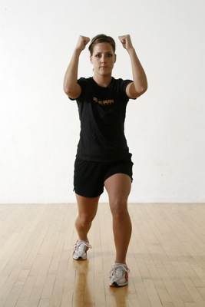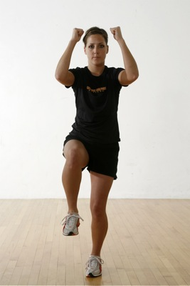

Snap Kick – The objective of the snap kick is to strike the assailant’s knee with the ball of one’s foot, making sure one has raised his/her toes up in order to reveal the proper striking surface of the foot. The back, or dominant, leg in the balance position is used. The striking target is the patellar tendon, located just below the kneecap.
Instructional Cues
- Balance Position
- Square hips to assailant
- Raise back leg so thigh is parallel to ground
- Extend leg toward target
- Kick with ball of foot (toes up)

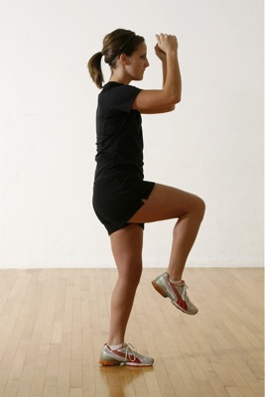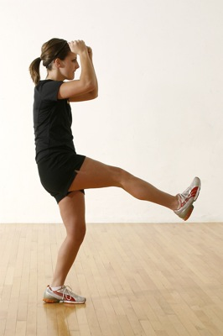

Hand Blow Techniques

Cupped Hand Blow – The objective of the cupped hand blow is to strike any of the head targets, including the side of the neck, Adam’s apple, nose, and back of the neck at the base of the skull, with the outside (pinky side) blade of one’s hand. The hand should be held in a “cupped” fashion with all fingers being squeezed together to strengthen the weapon. The back, or dominant, arm in the balance position is used. Similar to throwing a baseball, an effective blow is delivered by squaring one’s hips, pulling back the throwing arm, and following through with force.
Instructional Cues
- Balance Position
- Square hips to assailant
- Pull back arm (striking arm) into position while establishing cupped hand
- Strike target (similar to throwing a ball)
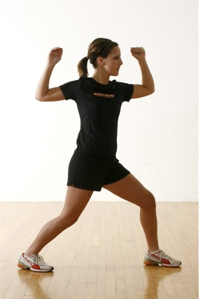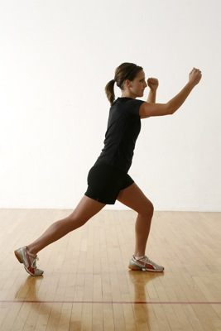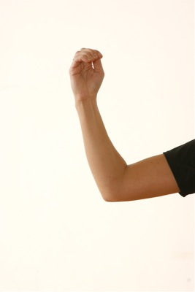

Open Hand Blow – The open hand blow is primarily intended to strike the nose of the assailant, however may be used effectively when striking other head targets such as the chin. This is a strike that could potentially prove fatal when the nose or chin are struck in an upwardly powerful motion. Therefore, safety when practicing is essential. To perform the blow, all fingers are bent over and the thumb is brought tightly in to meet the first index finger. The strike is delivered using the palm of one’s hand. The motion of the arm is similar to that of putting the shot rather than throwing a baseball.
Instructional Cues
- Balance Position
- Square hips to assailant
- Pull back arm (striking arm) into position while establishing open hand
- Strike target (similar to putting a shot)
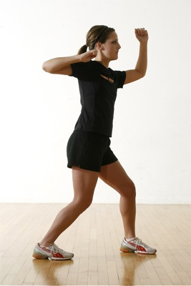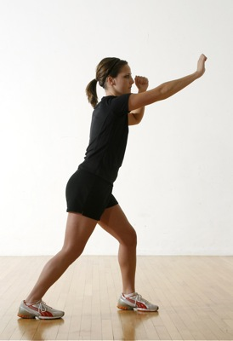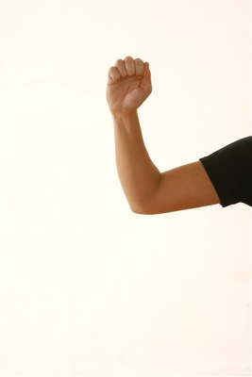

Finger Jab – The finger jab is intended to be used as a strike into an opponents eye, but may prove effective when directed to the neck region. Simply bring all fingers and thumb together to make one point. Keeping the wrist straight, the arm and hand take on the appearance of a spear. The point of the “spear” is used to strike the intended target and is much more stable than a single or pair of fingers would be. The back, or dominant, arm is going to be much more powerful.
Instructional Cues
- Balance Position
- Square hips to assailant
- Pull back arm (striking arm) into position while establishing point.
- Strike target (similar to throwing a ball)
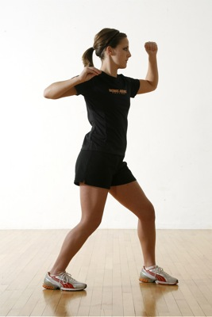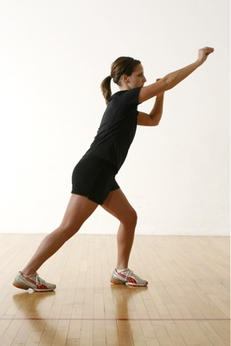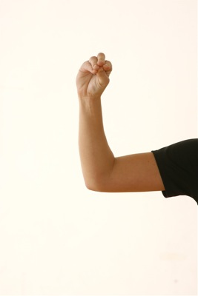
Releases from Wrist Grabs

Straight Across Wrist Grab (Single Hand) – A common scenario likely to occur in a face-to-face assault situation is for an attacker to reach straight out and grasp a victim’s arm or wrist. The victim is able to break the hold by first establishing a balance position and countering the attacker’s strength by backing away. It is important to remain relaxed, as the first instinct of most victims is to contract muscles and limbs when physically assaulted, thus bringing the attacker closer to one’s body. Next, the victim turns the thumb side of his/her grasped hand toward the attacker’s weakest link, visually seen as the gap between the attacker’s thumb and forefinger. In one fluid motion the victim “rips” his/her hand toward his/her chest by bending at the elbow, a very similar motion to a bicep curl.
Instructional Cues
- Balance Position
- Establish distance between attacker and victim by backing away/resisting attacker
- Turn thumb side of hand (radial side of arm) toward weakest link of attacker
- Pull hand through attacker’s weakest link – sideways motion, not a tugging motion
- Balance position and back away

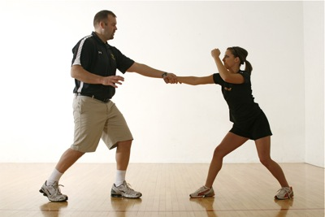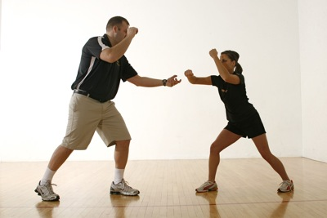

Two Hands on One Wrist Grab – In the event that an attacker grabs an individual’s wrist with both of his/her hands, one’s first response is to establish a solid balance position. When balance is achieved and the “window of opportunity” arises, the victim turns the palm of his/her grasped hand toward the sky and makes a fist. Next the victim reaches between the arms of his/her assailant, grabbing onto his/her clenched fist. Finally the victim breaks the hold by pulling his/her grasped hand through the attacker’s weakest link in their hold.
Instructional Cues
- Balance Position
- Establish distance between attacker and victim by backing away/resisting attacker
- Turn grabbed hand palm up and make a fist
- Reach in-between attackers hands and cover clenched fist
- Pull hand through attacker’s weakest links
- Balance position and back away

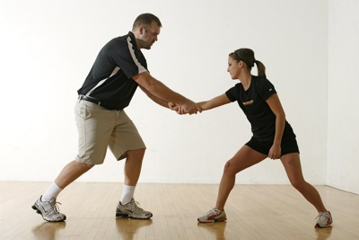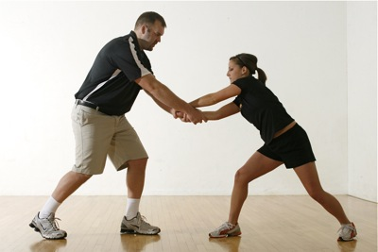
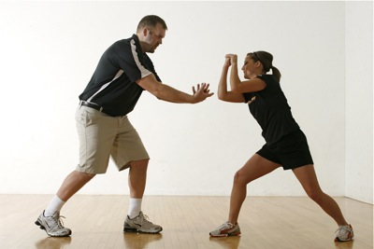

Releases from Lapel Grabs and Choke Holds

Aikido Release Technique – The objective of an Aikido release is to disengage the assailant’s hold on a victim’s lapel when grabbed in a straight across or cross body fashion. The key to success with this release in a face-to-face assault situation is to use the same-side body hand as that of the attacker. In other words, if the attacker has grasped the victim’s lapel with his/her right hand, the victim will use their left hand to break the hold. The victim simply drives their thumb into the back (metacarpal region) of the assailant’s hand and grasps the assailant’s thumb with their fingers. The victim is now in position to “peel away” the attacker’s grasp. The victim may now release the assailant by releasing the hold or continue to distract the attacker with toe stomps, kicks to the shin, or knee lifts. An Aikido release may be used on one-hand or two-hand lapel grabs.

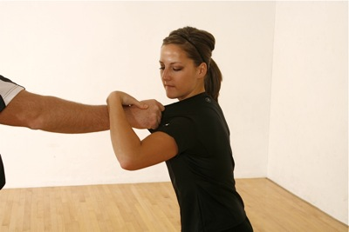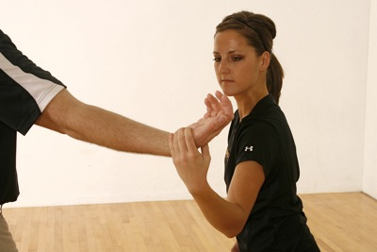

Swim Release Technique – The swim release is effectively used when a two-hand lapel grab or choke hold has been employed by an assailant. The victim should first establish a solid balance position. Once balance has been attained, the victim “swims” through the assailants grasp by reaching up and over the attacker’s arms with one of his/her arms. Once the victim’s elbow has risen above the attacker’s arms, the victim aggressively drives his/her elbow down and to his/her side. The power generated is typically enough to break a two-hand lapel grab or choke hold.

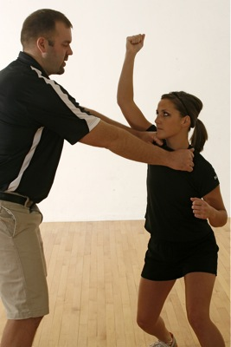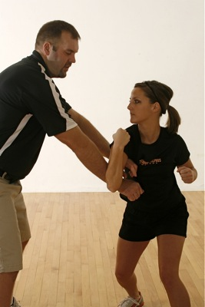

Wedge Release Technique – Another effective response to a two-hand lapel grab or choke hold is a wedge release. The victim first establishes a solid sumo-style balance position. Next the victim clasps his/her hands, bends at the elbows, and pushes them outwards, creating a “wedge”. The “wedge” is then driven straight up in-between the attacker’s arms and releasing their grip. From this position the victim may drive their clasped hands down upon the assailant’s nose or facial region.

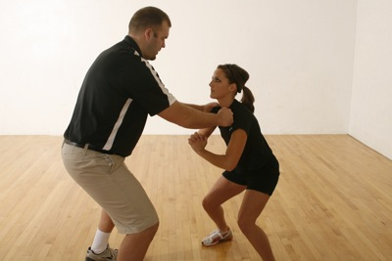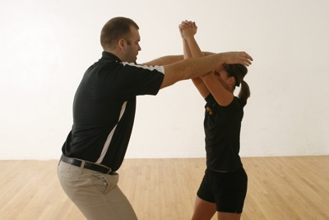

Additional Distractions – If the aggressor has established a very firm grip, or the victim is physically smaller or weaker than their attacker, the Aikido, Swim, or Wedge releases may not be effective. In this event, the victim may use other techniques to distract the assailant, loosening their grasp, prior to using any of the above mentioned release techniques. Strike as often as you can and as many times as necessary. Additional distractions, which are described below, discuss effective targets from the base to the head of the human body and are likely effective in any assault situation.

- Foot Stomps – Using the heel of your foot, drive down with all of your force onto the arch of your aggressor’s foot or their toes.

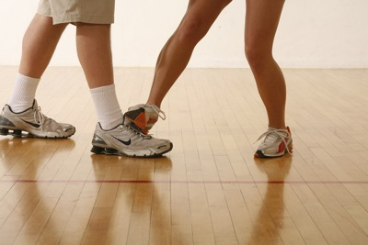

- Shin Scrapes – Using either the inside or outside of your foot, scrape down the front of an aggressor’s shin with the edge of your shoe.

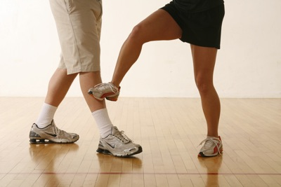

- Shin Kicks – Repeatedly kick into the front of your aggressor’s shin bones.

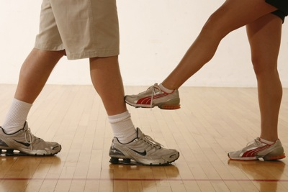
- Eye Gouge – This technique is particularly successful in a chokehold situation. To execute this distraction, bring your hands either around or inside the arms of your assailant. Place your hands on the aggressor’s head to stabilize it and drive your thumbs deeply and directly into their eyes. This technique may temporarily or permanently blind an assailant.
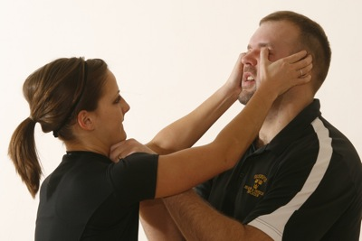

- Ears, Lips, and Hair Pulls – Another useful distraction is to aggressively grab and pull on the ears, lips, or hair of an assailant.
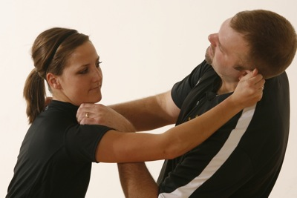

- Head Strikes – If both hands are free, hold the back of your attacker’s head with one hand while striking with the other. Particularly effective strikes include cupped hand blows, open hand blow, or finger jabs directly focused upon the eyes, nose, and throat. Clawing, scratching, pinching, and biting are also recommended.
