Psychological Skills Training: Self-Talk Skills
written by Dr. Christine Lottes

Athletes’ thoughts can either enhance or hinder performance. Continuing our Psychological Skills Training series in pelinks4u, today’s article provides a script for the coach, and, 2 reproducible handouts (one a script for the coach plus a handout for athletes) as we look at how athletes can successfully manage their self-talk.

Coach’s Script for: Self-Talk Skills

Bring to practice: coach’s script, a copy of the athlete’s handout for each athlete (follows the coach’s script), pencils or pens, chalk

Self-Talk
This lesson will take two hours. It can be broken up into 2 different sessions.

Review:
- Relaxation means decreasing unwanted muscular tension & calming the mind.
- Total relaxation is a longer strategy that helps athletes relax completely. Rapid relaxation is an abbreviated technique that uses a cue word to relax quickly.
- Relaxation includes deep breathing, imagery, relaxation, muscle relaxation and cue words.
- Energization helps athletes control arousal, enhance concentration and elevate confidence, particularly when they are tired, encountering adversity or dealing with low energy levels.
- Energization includes psych-up breathing, imagery energization, muscle activation and cue words.
- The cued words is associated with feelings of high energy and, in rapid energization, can occur in 3-5 seconds.

Check-up from First Session:
- Look in your notes from the end of our first session where you listed an action you’d take to deal with something you were concerned about. Did you do it? Volunteers to share. Continue with taking action with things you can control.

Today: Self-Talk
- Self-talk is the steady stream of thoughts and internal dialogue that goes on in our heads almost constantly. Your thoughts have a major impact on your mood, emotions and performance.
- Make a list of thoughts you had so far today:

- To make self-talk work for you, you want to increase positive thoughts and decrease negative thoughts as your thoughts will affect your sport performance and all other areas of your life.
- Positive self-talk leads to a flow mind-set in which you will excel athletically.
- Negative self-talk leads to a choking mind-set in which irrational thoughts can cause you to underachieve.
- When an event happens to you, you have beliefs about the situation- how you interpret what has happened. This interpretation of the situation determines your emotions and behavior to a much greater extent than does the situation itself.

- Let’s look at an example of this. (Coach, you can rewrite this for your sport....)

Self-Talk Model Self-Talk Examples
A = Activating Event Our team must defend against a potentially game- winning penalty stroke in the state championship.
B = Beliefs (Thoughts) - “I really will be a rotten goalie if I let this player make this stroke. I’ll never have such a great opportunity to be the hero again- don’t blow it!”

+ “ I’ve prepared well for this moment. Even though this is a pressure-packed moment I’m confident I can defend against this stroke.”

C = Emotional Consequences - Stress/anxiety
+ Challenge/excitement

C = Athletic Consequences - Disruptive behaviors such as feeling tense and flustered; poor concentration; slow to pick up the ball coming off the opponent’s stick; slow reaction to the ball.

+ Helpful, constructive behaviors such as being focused and confident; quick to pick up and react to the ball.

Depending on the age of your athletes, either do the following together as a team or have each athlete complete his/her own. If completed individually, take them home and check them over, make corrections, etc.

Self-Talk Model Self-Talk Examples
A = Activating Event

B = Beliefs (Thoughts) -

+

C = Emotional Consequences -

+

C = Athletic Consequences -

+

- The basic principle of self-talk is that we can’t always control what happens to us, but we can control how we respond to uncontrollable events.
- Our self-talk comes from either positive or negative thinking.
- Positive thoughts help performance while negative thoughts hurt performance.
- We’ll call positive thought patterns smart-talk.
- Eight rules of smart-talk”
  - Be an optimist, not a pessimist: self-talk is a choice. Focus on what you can control, not on what you can’t.
  - Remain realistic and objective: make goals you can achieve.
  - Focus on the present, not the past or future: it is the only thing you can control.
  - Appraise problems as challenges rather than threats: this keeps you motivated and performing up to your capabilities.
  - View successes as replicable and failures as surmountable: view success as due to ability and effort. Attribute failure to factors you can control such as effort level (I’ll work harder next practice), skill development (I can learn to read my opponent better) and mental preparation (next time I’ll improve my focus).
  - Concentrate on process, not outcome: focus self-talk on process goals- hard work, mental preparation, skill and strategy development- that you can control and will lead to outcome goals. Ex. In the seconds before the penalty corner concentrate on “stopping the ball and follow-through on the shot” or “explode out, stick-to-stick” or “explode out, set, ball” or “explode back (from 50) and into position”. (NOTE to Coach: Change this to line up with the Self-Talk Model you revised for your sport.)
  - Concentrate on things you can control: Can’t control people and some events (opponent’s behavior, officials’ decisions, playing conditions). Can control your emotions and behavior.
  - Separate your performance from your self-worth: Your worth has nothing to do with how you perform. It has everything to do with who you are as a unique creation who is loved regardless of your performance.
- Negative Thought Patterns: watch for distorted thinking and irrational beliefs.
- Distorted Thinking: catastrophizing (expecting the worst and exaggerating the consequences), overgeneralization (just because make a mistake think that always mess up), blaming (holding others responsible for negative events in my life), mustification (things must be my way) and polarized thinking (one way or another- I’m a success or a failure).
- Irrational Beliefs: perfectionism (I have to never make mistakes), fear of failure (some failure is normal), social approval (everyone must like me), equity (life must be fair, I should play well and get the rewards I deserve if I work hard) and social comparison (putting too much importance on largely uncontrollable outcomes, such as winning and outperforming others rather than concentrating on controllable factors such as playing your best.)
- Optimizing Self-Talk:
- Awareness of current self-talk patterns
  - Imagery recall: Close eyes and think about a competition that you played very well. Now write down some specific thoughts you had during the competition that helped you succeed. Now think about a poor performance. Now write down your thoughts during that competition. Compare the two lists and identify positive and negative self-talk patterns that most affect your performance. Use Self-Talk Log.
  - Negative Thought Counts: On your own- Put a number of paper clips, pennies or sunflower seeds in a pocket, Each time you catch yourself using a negative thought, move one item to a different pocket.
  - Goal is for negative thoughts to decrease.
- Post practice and Competition Logs- see me if want to work on this area more and I’ll set this up for you. See next page for Positive Mental Attitude Self-Talk Log.

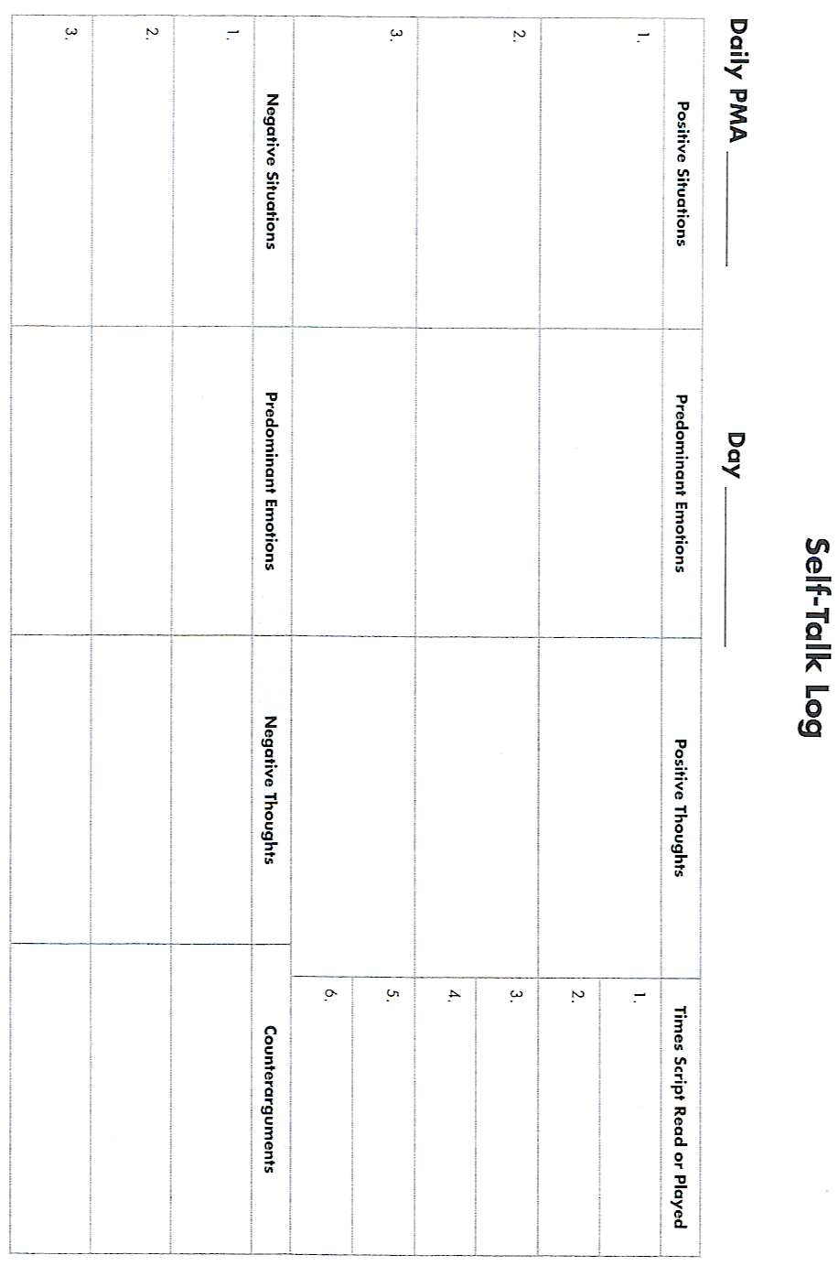
From D. Burton and T. Raedeke, 2008, Sport Psychology for Coaches (Champaign, IL: Human Kinetics).
- Program Positive Thoughts: increases confidence, improves concentration and focus, enhances motivation, controls stress and so increases performance.
- Positive affirmations: I’m a talented athlete with the skills to get the job done.
- Team mottos or Motivational slogans: “Footwork is the key to success.” “Suffocating defense.” “No less than all.”
- Cue words: “relax”, “ball”, “one play at a time”, “I play well every time I take the field”, “smooth swing”, “stick with what’s working”, ”hustle”. (Coach, you can rewrite these for your sport....)
4. Reframe Negative Thinking: Negative thoughts will still occur and can lead to negative emotions and sub par performance. To correct them follow the “3 Ds” of reframing:
  - Detect negative, unproductive or irrational thinking: what was the thought that preceded feelings of stress or other negative emotions?
  - Disrupt negative thoughts by either thought stopping or thought changing: Say “Stop” and think of a red stop sign, red flag or flashing red lights. Or, use a behavioral cue- snap finger or snap a rubber band when have a negative thought. Thought changing works like a TV remote control to simply change the channel from one with negative thoughts to another that is more positive and productive.
  - Dispute negative thoughts by using effective counterarguments. They function like a good lawyer, putting faculty beliefs on trial, refuting them with logical arguments and identifying logical, realistic, productive thoughts to take their place. Ex. I want more playing time and I worry that my coach doesn’t like me. A counterargument will reduce my anxiety- “I can’t control what my coach thinks or how much she decides to play me. I need to concentrate on what I can control and play my best by focusing on footwork and positioning when I don’t have the ball.” (Coach, you can rewrite this for your sport....)

- Do Worksheet for Reframing Thoughts.

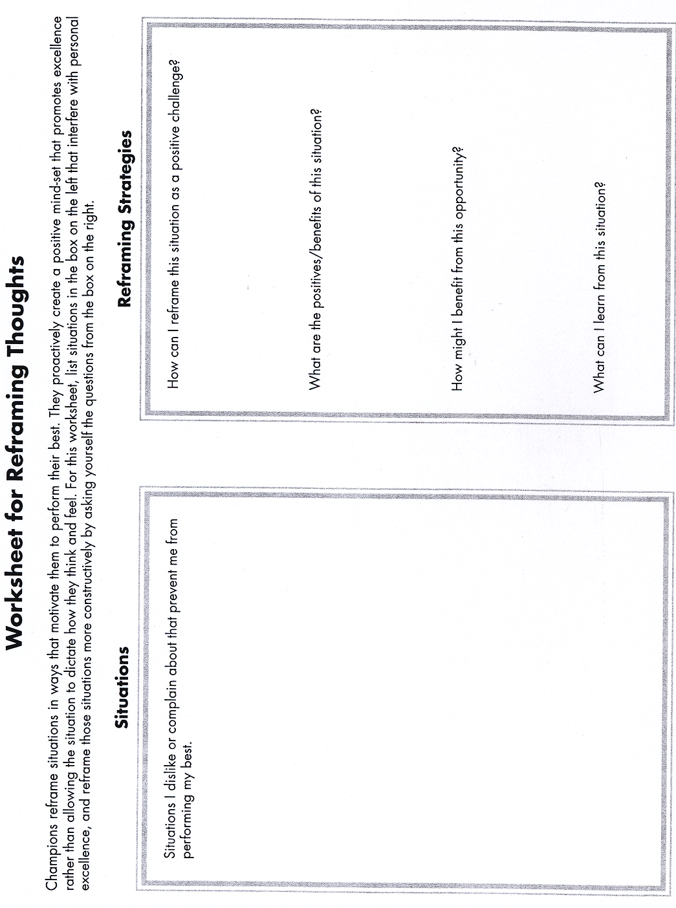

Adapted, by permission, from K. Ravizza and T. Hanson, 1995, Heads up baseball: Playing the game one pitch at a time (Indianapolis, IN: Masters Press), 3d, by permission of the McGraw-Hill Companies. From D. Burton and T. Raedeke, 2008, Sport Psychology for Coaches (Champaign, IL: Human Kinetics).
- Develop a self-talk script:

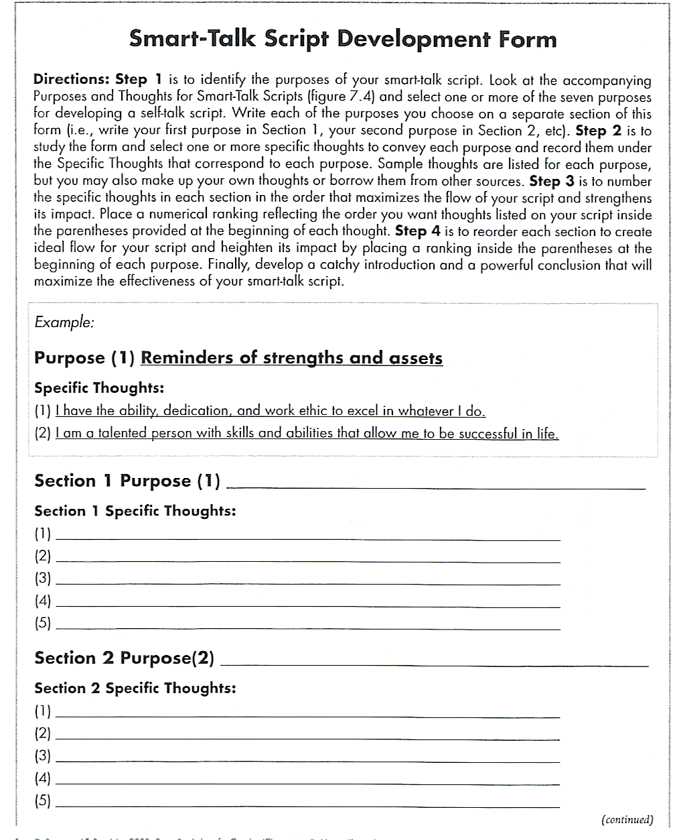

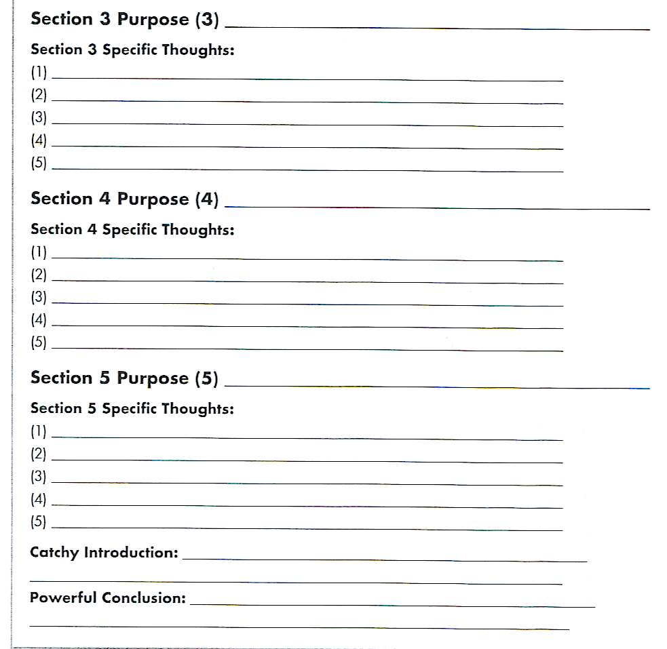

From D. Burton and T. Raedeke, 2008, Sport Psychology for Coaches (Champaign, IL: Human Kinetics).

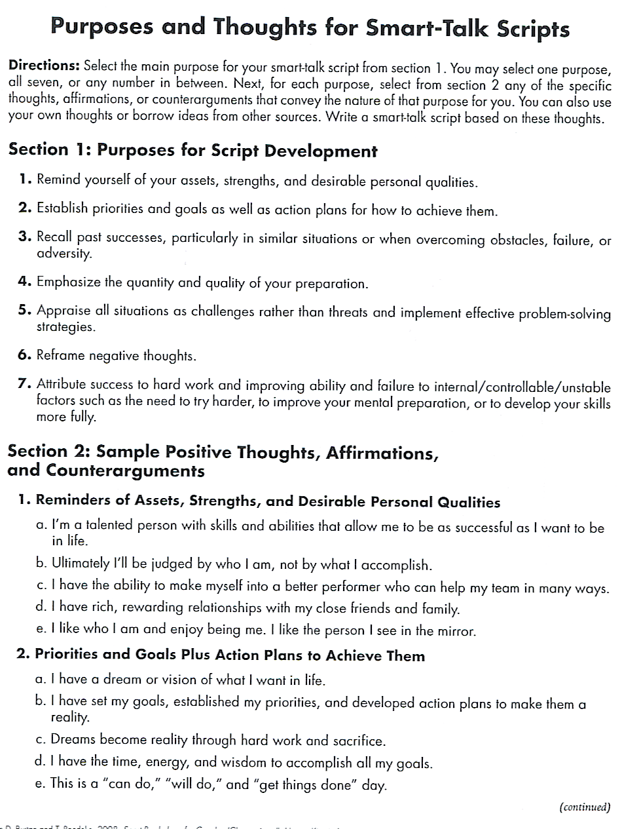
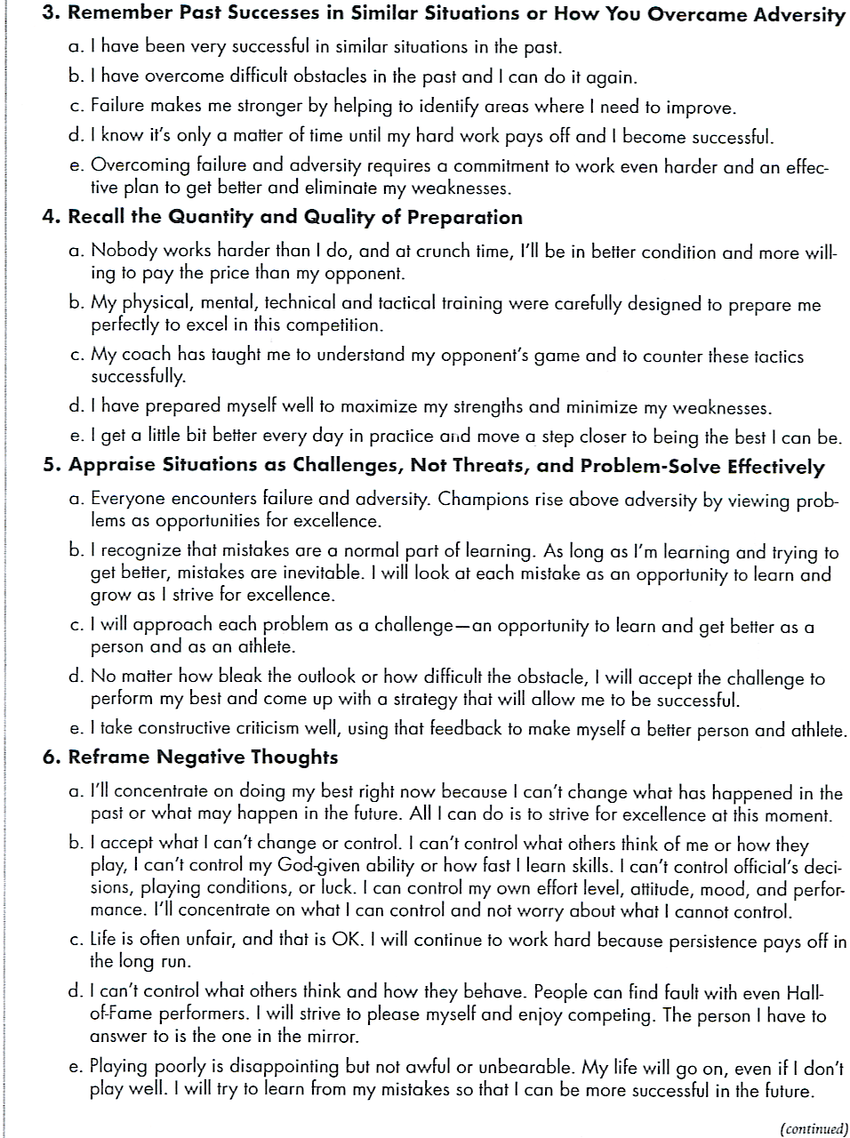

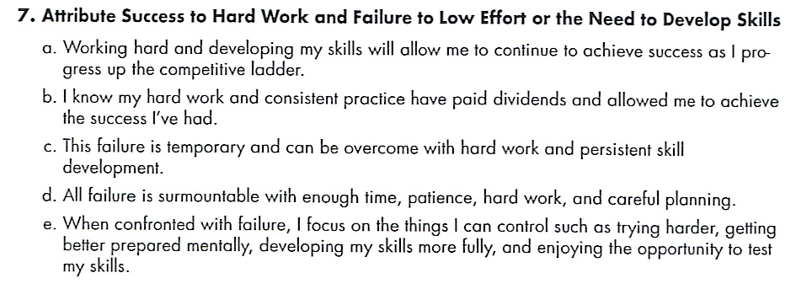
From D. Burton and T. Raedeke, 2008, Sport Psychology for Coaches (Champaign, IL: Human Kinetics).

- Read your script, or record it and play it, 4-5 times per day. Prime times to read or play scripts include first thing in the morning, last think at night, on the way to class, during study breaks, and before and after practice.
- When a negative thought occurs, remember the three Ds of the reframing process: Detect, Disrupt and Dispute each negative thought and replace it with one that is more positive and productive. Refer to chart of Self-Talk Dos and Don’ts.
- Keep a list of negative situations they have difficulty reframing. Several times a week intensely imagine one and the corresponding negative emotions before using reframing skills to counter faulty thinking. Can build counterarguments for situations that are particularly problematic into their smart-talk scripts.
- When utilizing Self-Talk in practice or games, here as some helpful “Dos and Don’ts”.
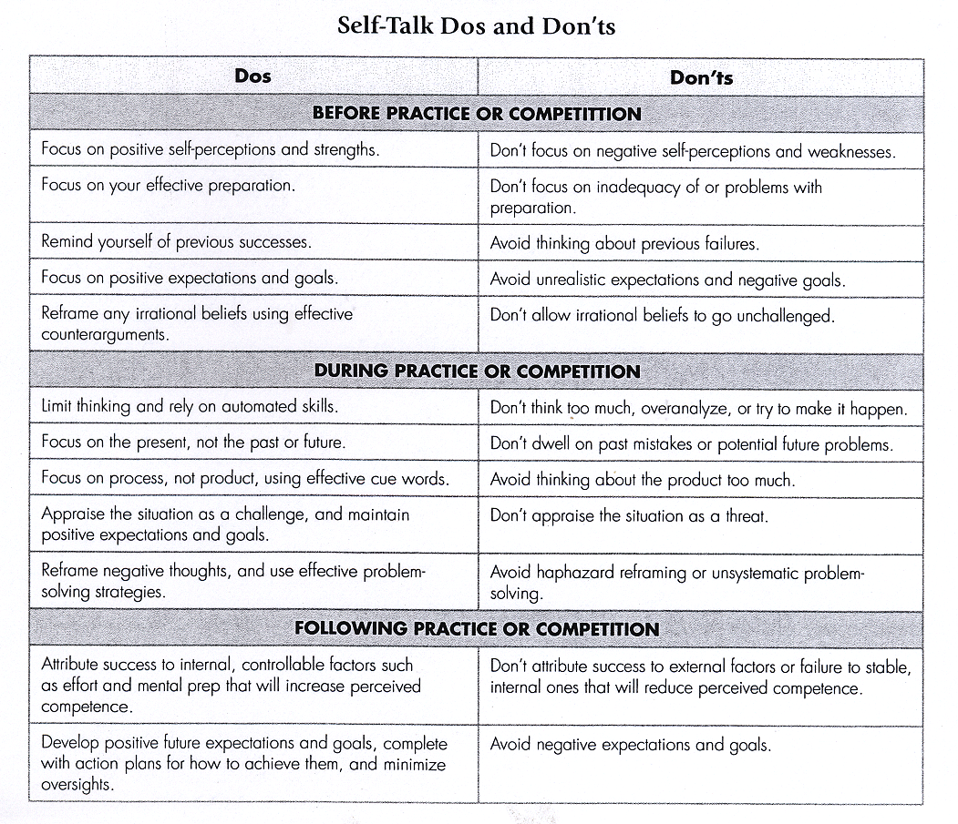
From D. Burton and T. Raedeke, 2008, Sport Psychology for Coaches (Champaign, IL: Human Kinetics).

Summary
- Self-talk is the steady stream of thoughts and internal dialogue that goes on in our heads almost constantly. Your thoughts have a major impact on your mood, emotions and performance.
- The ABCs of self-talk describe how thoughts affect emotions and behaviors. A= activating event; B= your belief or interpretation of the situation and it determines your emotions and behavior to a much greater extent than the situation itself does; C= is the consequence- how you feel and act afterward.
- Successful self-talk requires recognizing and changing negative thoughts.
- You can combat distorted and irrational thinking by using counterarguments to reframe your thoughts.
- The best way to program positive self-talk is to develop a short, smart-talk script and read or play it 4-5 times daily.
- To reframe a negative thought use the three Ds- detecting, disrupting and disputing negative thoughts.

Upcoming June/July article on Mental Training…….
In the June/July edition of pelinks4u we will be discussing energy management. Energy Management utilizes either relaxation or energization (see December issue of pelinks4u for how to train athletes in relaxation/energization) to get into an optimal energy zone for practice and competition.. A script for the coach and a reproducible handout for athletes will be provided.

